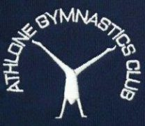
Use of Photography/Video Policy: P
- On our Club website, if the gymnast is named then we avoid using their photograph and if a photograph is used then we avoid naming the gymnast

- Parental permission is requested to use their child’s image. This ensures that they are aware of the way the image is to be used to represent the sport.
- The PRO will be made aware of any children who do not wish have photos taken or posted on website or club Facebook page.
- We only use images of gymnasts in suitable dress to reduce the risk of inappropriate use.
- The content of the photograph will focus on the activity not on a particular child

- Recognised procedures for reporting the use of inappropriate images to reduce the risks to gymnasts are in place and observed.
- VIDEOING AS A COACHING AID: Video equipment can be used as a legitimate coaching aid. However, permission will first be obtained from the gymnast and the gymnast’s Parents/Guardians/carer. Club equipment only to be used and all videos & images to be deleted after each session. Club photography / video equipment to be kept securely in locked cabinet in office.

